**Karp Emissions Estimation Project – Meeting notes for 9/13/22**

Aaron Watt

Observed emissions (1945-2005)

Predicted emissions for sigma^2s ~ 100

Predicted emissions for sigmas ~ 10^10

Predicted emissions for sigmas ~ 10^12

Log Likelihood function, sigma_a^2 on x-axis, sigma_u^2 on y-axis

Log Likelihood (flat in sigma_a direction)

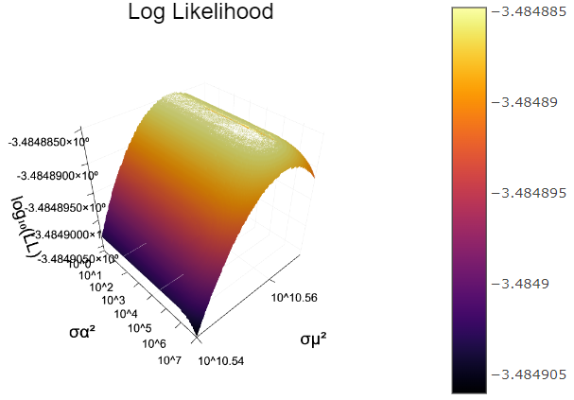

This looks pretty straight (constant maximum in the sigma_u direction).

But the scale that sigma_a is changing the LL function is very small compared to sigma_u.

I could trace out the maximum ridge if wanted to determine if it’s slightly diagonal.

Fix sigma_u^2 at 10^10.56 (sigma_u ~ 190,000 – on the order of magnitude of year-over-year changes)

Plot LL as a function of sigma_a

It appears thought that for any fixed sigma_u, sigma_a = 0 maximized the LL function.

The lowest LL I’ve been able to achieve in MLE interations in simulated data: -2754

MLE on both simulated data and real data drive sigma_a to 0.

To trace out the ridge:

* fix sigma_a at many values from 10^-2 to 10^4
* find max of LL in sigma_u direction

My current prior is that the LL is maximized at roughly sigma_u ~ 10^10.56 and sigma_a = 0.

Could it be that the model is best fit when there is no shared year shock, just the region-year shocks?

Could mean that there is too much difference between countries trends to pick up shared year shocks when idiosyncratic shocks are also present.

*Experiment:

* fix sigma^2_u
* simulate data with very different values for sigma^2_a (0.1, 10^12, 10^13)
* look at variance in time series data
* perhaps look over many MC simulations and calculate CI’s for different sigma_a's

* Need to fix the optimization routine:

- Try using adaptive step size algorithms (from Algorithms for Optimization 2019)

- 5.6 RMSProp

- 5.7 Adadelta

- 5.8 Adam adaptive moment estimation method

-

- Decrease the tolerance to see if it will run all the way to the ridge from anywhere

- if that doesn’t work, may need to figure out how to weight the different components of the gradient differently.

What is the statistic that reflects the role of sigma_a?

* Take many draws
* detrend data
* Is there a way to aggregate the data and estimate just sigma_a without sigma_u?

*Andy:

* Aggregate the data, estimate the variance = sigma_a^2 + sigma_u^2/n (use simulated data too! First? To see if this still holds)
* Use cross-sectional data to estimate sigma_u^2
* Estimate sigma_a^2 = sigma_a^2 + sigma_u^2/n – sigma_u^2/n
* Think through the aggregation steps, write up the steps and email Larry to confirm the steps are correct

Low priority test that Aaron thought of:

Test if the the sample size (n) is an issue: try simulating date with n=100 and see if sigma_a still goes to zero?

Next meeting: Tuesday Oct 4, 2pm PT